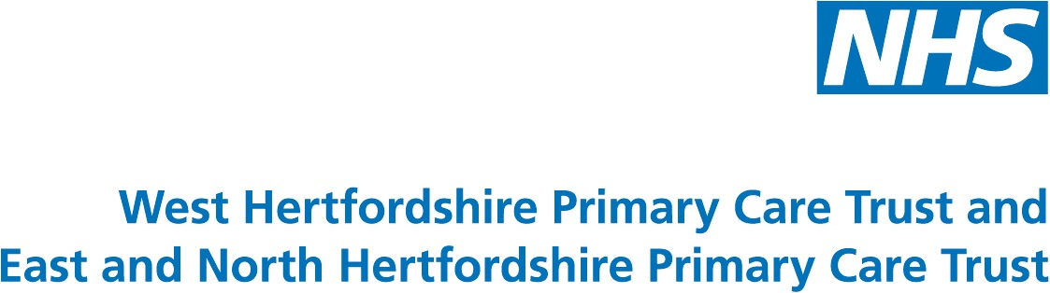
Long Term Conditions Workshop
Challenges from the Darzi/ EoE Report

Focolare Centre for Unity, 69 Parkway, Welwyn Garden City, AL8 6JG

22nd July 2008, 13.30pm – 16.00pm

Welcome, introductions and format of the afternoon:
Moira McGrath

1.30pm – 14.00pm LTC Pledge 7 from EoE Strategy: Towards the Best, Together
Dr. Steve Laitner

14.00pm – 14.20pm LTC Access to Psychological Therapies: including

Medically Unexplained Conditions
Wayland Lousley

14.20pm – 14.40pm Diabetes & Patient Involvement (Case Study)
Liz Gregory

14.40pm – 14.45pm Care Planning
Moira McGrath

14.45pm – 15.00pm Coffee

15.00pm – 16.00pm Breakout Session

- Care Planning: Who coordinates the Care Plan (CP); issues & resources for CP implementation; who will take this forward locally?
Facilitators: Janet Lewis

  - Patient Involvement: Should it be generic or specialty based?

How should they be involved in the commissioning cycle? –

Facilitators: Heather Aylward

  - Information Sharing: Should we have patient-held paper records? What are the interim solutions prior to the implementation of the new IT system?
Facilitators: Moira McGrath

- Clinical Networks: How will Clinical Networks support new ways of working? Are they Fit for Purpose?
Facilitators: Janice Omar

4.00pm Feedback & Close


